**Assignment 7 – Part 2  
Set 9.4 - 6, 7, 16, 27**

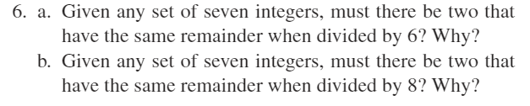

**6.a.) Yes. There are 7 objects and only 6 possible remainders.**

**6.b.) No. There are 7 objects and 8 possible remainders. Counterexample: 0, 1, 2, 3, 4, 5, 6. None have the same remainder when divided by 8.**

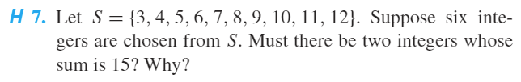

**7.) Partition set S into four disjoint subsets: $$\left\{3,12\right\},\left\{4,11\right\},\left\{5,10\right\},\left\{6,9\right\},\left\{7,8\right\}$$ 
Yes. Each of the integers in S occurs in exactly one of the 5 subsets and the sum of the integers in each subset is 15. Thus, if six integers from S are chosen, two must be from the same subset. It follows that the sum of these two integers is 15.**

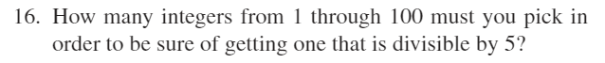

**16.) 20 integers are divisible by 5 from 1 through 100. 80 are not. It is possible to pick 80 integers not divisible by 5, but then it follows that the next integer picked will be divisible by 5. Thus, 81 integers must be picked.**

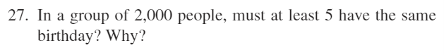

**27.) $\frac{2000}{365}=5.48$ $$ceil\left(5.48\right)=6$$ Thus, at least 6 people have the same birthday.**